 | Nelson Mandela Statue Unveiling Event  Friday 9th October 2026 @ 4PM  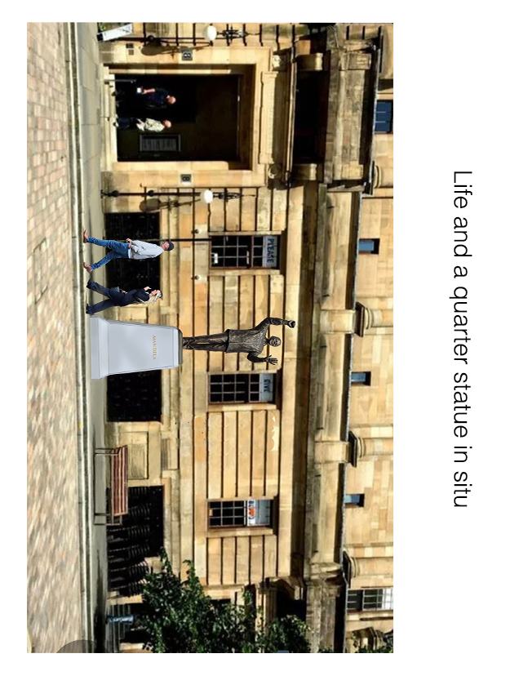  Artists Impression: New Statue to Nelson Mandela in Nelson Mnadela Place, Glasgow  The date has arrived! This splendid statue to Nelson Mandela has finally been completed. It is ready to be installed in its final situation in Nelson Mandela Place, Glasgow.  The Unveiling Event will be a public event, and we hope many people will attend. The formal ceremony will start at 4 pm with some music from 3.30pm and is expected to last an hour with attendees dispersing soon afterwards.  We hope you can join us to celebrate this major milestone.  Friday 9th October 2026 @ 4PM
  Public Unveiling Event: Nelson Mandela Place
  Nelson Mandela Scottish Memorial Foundation
  https://mandelascottishmemorial.org/
  Chair: Brian Filling
  b.filling@btinternet.com
  Vice Chair & Project Manager: Janis Carson
  jmgcarson@gmail.com
  Secretary: John Nelson
  Johnnelson48@yahoo.co.uk
  More information on the Nelson Mandela Scottish Memorial Foundation and the statue can be found at:
  https://mandelascottishmemorial.org/

